5/22/2026
Shekhar Podutwar
22/5/2026
Apache Web Server CI/CD Implementation on AWS EC2 Website Deployment Pipeline

Contents

Document Version History……………………………….…………………………………………….1
Introduction…………………….…………………………………………………………………………….2
Objectives…………………….………………………..….………………………………………………….3
Tools & Technologies Used…………………………………………………………………………….4
Architecture Overview ………………………………………………………………………………….5
Step-by-Step Implementation …………………………………..………………………………….6

Document Version History

Version Number | Date Modified | Author | Changes
Draft | 22/5/2026 | Shekhar | Draft Version

Introduction
This project focuses on implementing an automated deployment pipeline for hosting web applications on an Apache HTTP Server using Azure DevOps and Amazon Web Services EC2 infrastructure. The objective of the project is to automate the process of building, deploying, and managing website or application files on an Apache web server through a CI/CD pipeline.
The pipeline was configured to automatically fetch source code from a Git repository, execute build and deployment tasks, and deploy application files to a Linux-based EC2 instance hosting the Apache web server. The server was securely connected and managed using SSH and deployment automation techniques.
This implementation demonstrates practical DevOps automation by reducing manual deployment efforts, improving deployment consistency, and enabling faster application delivery through continuous integration and continuous deployment practices.

Objectives
The primary objective of this project is to automate website deployment on Apache Web Server using Jenkins pipeline implementation.
The project aims to:
- Deploy and configure Apache Web Server on AWS EC2.
- Automate build and deployment workflows using Jenkins
- Integrate source code repositories with deployment pipelines.
- Reduce manual deployment activities.
- Improve deployment consistency and release speed.
- Enable automated application delivery to Linux servers.
Tools and Technologies
Tool / Technology | Purpose
Amazon Web Services (AWS EC2) | Cloud server hosting
Linux (Ubuntu/Amazon Linux) | Operating system
Apache HTTP Server | Website hosting
Git / GitHub / Jenkins | Source code management
YAML Pipelines | Pipeline configuration
SSH / PuTTY | Secure remote server access
HTML / CSS / JavaScript | Website frontend files
Systemctl Services | Apache service management

Architecture Overview
Developer Code Commit
│
▼
GitHub Repository
│
▼
Jenkins CI Pipeline
(Build & Validation)
│
▼
Artifact Generation
│
▼
Jenkins CD Pipeline
(Automated Deployment)
│
▼
AWS EC2 Linux Server
│
▼
Apache Web Server
│
▼
Hosted Web Application
Step-by-Step Implementation
Step 1: Perform following steps
- Login AWS and create an instance
- Connect putty
- Open port no 8080
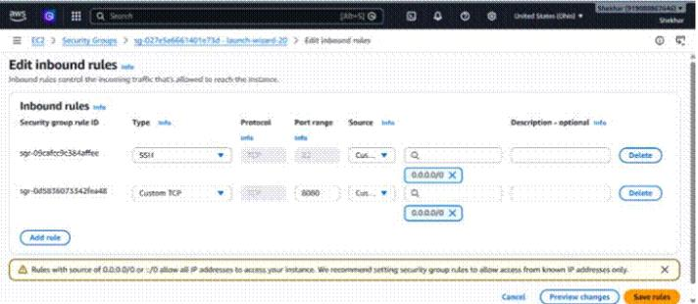
Step 2: Create a job in Jenkins
- Now you can create job in Jenkins
- New item--> job--> pipeline
- Pipeline --> script (add pipeline script)
- Apply and save
- Build job

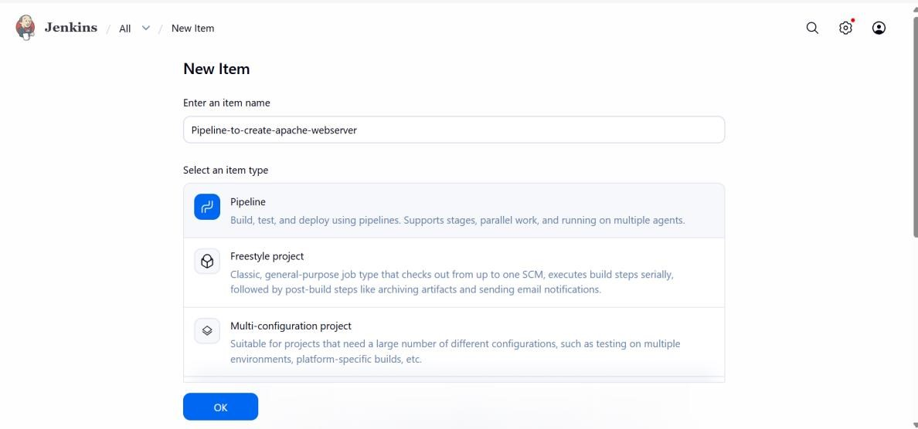
Step 3: Pipeline Script

pipeline {

agent any

stages {
stage ("update repo") {
steps {
sh "sudo apt update -y"
}
}

stage ("install apache2 package") {
steps {
sh "sudo apt install -y apache2"
}
}

stage ("start apache2 services") {
steps {
sh "sudo systemctl start apache2"
}
}

stage ("create a html file") {
steps {
sh "echo 'Great job Shekhar keeps shining' | sudo tee
/var/www/html/index.html"
}
}
}
}

Step 4 default Jenkins directory
- Now you can create job in Jenkins
- Default
- home directory (cd /var/lib/jenkins/)
- workspace directory of Jenkins (Workspace/project name)

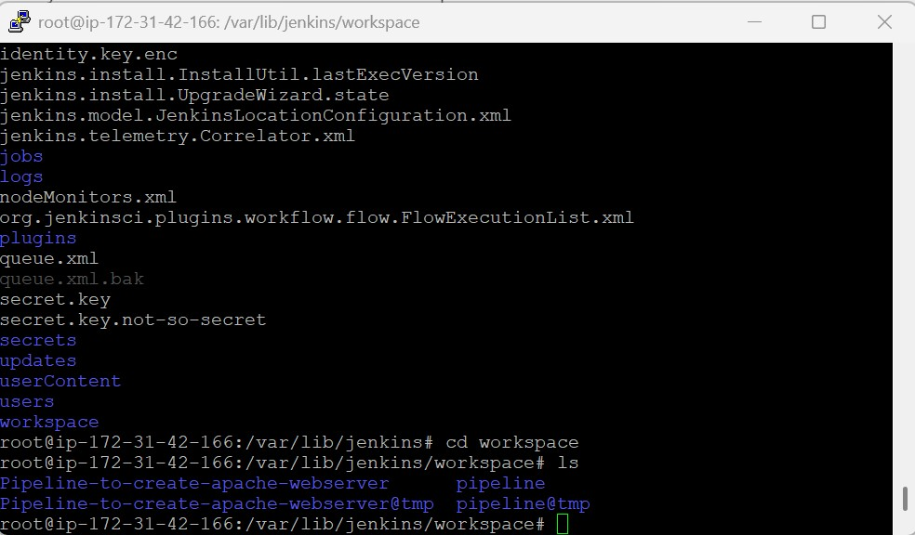

Step 5: Open http port in browser (port: 80)



Conclusion
The Apache Web Server Deployment Pipeline implementation provides an automated and scalable solution for deploying web applications on AWS EC2 infrastructure. By integrating Jenkins pipelines with Apache Web Server, the project enables continuous deployment, reduces manual intervention, and improves deployment efficiency and reliability. This implementation demonstrates practical DevOps automation and modern application deployment practices in cloud environments.

